Is your LED blinking? Congratulations. Doesn’t it feel so amazing when an electronics project works?
Is your LED not blinking? Congratulations. You now get to be an engineer.
Because, more than anything else, the job of an engineer is to keep trying.
This is something my grandpa taught me. Making things that work is less about How much do you know? and more about How hard did you try?
Most inventions don’t work the first time.
Or the tenth.
Or the twentieth.
The difference between someone who changes the world and some who doesn’t might literally be one more try at it.
America’s most famous inventor, Thomas Edison, is famous for trying thousands of times to get the light bulb to work. To get the right material for the filament of a light bulb, which is just one step of the process, he and his team tried more than 2,700 materials! After they finally got the light bulb working, a reporter asked Edison about his 10,000 failed attempts and he said this:

I have not failed 10,000 times. I have not failed once. I have succeeded in proving that those 10,000 ways will not work.

If your circuit isn’t working yet, go back to the previous chapter and check:
- Did you line up all the wires and connections in the right rows on the breadboard?
- Did you insert the LED with the long legs facing the positive rail on your breadboard?
- Did you write every line of the code correctly?
- Is your LED burned out?

“If you’ve checked everything and it still doesn’t work, don’t give up. Seek out help instead.”
I had help from my grandpa. If you don’t have another person in your life who knows how to do this, you can get help from the Internet.
May I recommend a certain lovely book by a brilliant author named…Sparky McVoltage?
That’s right, the book my dad bought at the estate sale, Simple Robots for Clever Humans….it turns out that it’s available to anyone. Sparky McVoltage put his entire book online. It’s a wonderfully chaotic, delightfully strange web site, and in addition to the full text of the book, it also includes some accompanying videos.
His videos are funny. Whoever he is (he never seems to show his face), he teaches Arduino like he’s narrating a heist movie.
In fact, even if you’re not stuck, even if your circuit is already working, I think you should check out Mr. McVoltage’s web site.
www.sparkymcvoltage.com
You can also follow this QR Code.
In the last chapter, I only had time to show you the code that Grandpa helped me write, but if you want to be serious about electronics, engineering, and robotics, you should learn what the code means, how it works, and most importantly, how to write your own.
Sparky McVoltage will teach you all of that, and a whole lot more.
In fact, I insist you go and spend some time on sparkymcvoltage.com right now, learn more about building circuits and programming microcontrollers, and then come back to this book when:
a) your circuit is working, if it isn’t already
b) you understand more about what the code is and how it works.
See you when you return!

Here’s the first part of the code:
// Blink an LED connected to digital pin 13.
// ON for one second, OFF for one second, forever.
These are called comments. In C++, when you type two backslashes like this:
//
you’re telling the computer, “The rest of this line is a note for me and anyone else reading the code,” and that’s what those lines are. We say
// Blink an LED connected to digital pin 13
as a kind of title to the code so anyone reading knows what this program is, and we say:
// ON for one second, OFF for one second, forever.
to explain exactly what this program does.
Then we get into the actual code.
void setup() {
pinMode(13, OUTPUT);
}
That block you just read tells the Arduino to setup Pin 13 as an Output pin, meaning any wire pluged into Pin 13 is going to have an electrical signal come from the Arduino and out through the wire to whatever’s connected.
Now we’re into the heart of it.
void loop() {
digitalWrite(13, HIGH);
delay(1000);
digitalWrite(13, LOW);
delay(1000);
}

That is the program. It’s a loop because it runs over and over again.
digitalWrite is called a function, and first it tells Pin 13 to turn on, or send a HIGH electrical signal. Then the delay function has the program wait for 1000 milliseconds before moving to the next line. Then digitalWrite again, only now Pin 13 is turning off, or having a LOW electrical signal. Another 1000 milliseconds of delay finishes the loop, and then the loop starts again, over and over, for as long as the Arduino stays powered on.
In other words, this program turns an electrical current, outputting from Pin 13, on and off again, with 1000 milliseconds (or 1 second) in between each blink.
And voila! You have a blinking LED!
(sketch of blinking LED on breadboard)

Instead, go to

For me, the programming didn’t come easy. In fact, writing that first program for the Arduino wasn’t one of those movie montages where the hacker hero types fast and yells, ‘I’m in!’ It was three hours that evening of trial, error, and me wondering why my LED refused to blink.
Here’s the code I wrote.
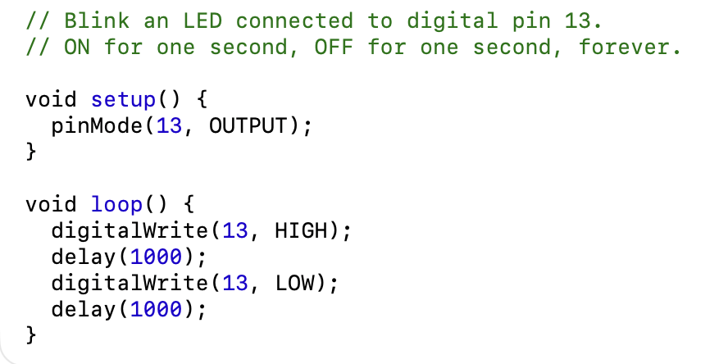
I wish I could tell you I wrote that code from scratch and am well on my way to being a master programmer who makes microcontrollers kneel before my will.
Except I copied that code, line by line, from Sparky McVoltage, author of Simple Robots for Clever Humans.
He put that code in Chapter 3 of his book. In the chapter, he also explained, step by step, how to hook up the Arduino to the computer, how to download the coding software, how to upload the code…
It turned out he even had a web site with videos on how all this works. His videos are funny. Whoever he is (he never seems to show his face), he teaches Arduino like he’s narrating a heist move.
Are you building along with me as you read? You should be. If you want to build this circuit, make it work, and understand all the code, I need you to now go to Sparky McVoltage’s web page:
www.sparkymcvoltage.com
Find the lesson called “Chapter 3: Your First Arduino Build.”
You can follow the QR code in the margin to go straight to the web site. Don’t worry, I’ll still explain the important parts here. In fact, let’s go through that whole program.
Here’s the first part of the code:
// Blink an LED connected to digital pin 13.
// ON for one second, OFF for one second, forever.
These are called comments. In C++, when you type two backslashes like this:
//
you’re telling the computer, “The rest of this line is a note for me and anyone else reading the code,” and that’s what those lines are. We say
// Blink an LED connected to digital pin 13
as a kind of title to the code so anyone reading knows what this program is, and we say:
// ON for one second, OFF for one second, forever.
to explain exactly what this program does.
Then we get into the actual code.
void setup() {
pinMode(13, OUTPUT);
}
That block you just read tells the Arduino to setup Pin 13 as an Output pin, meaning any wire pluged into Pin 13 is going to have an electrical signal come from the Arduino and out through the wire to whatever’s connected.
Now we’re into the heart of it.
void loop() {
digitalWrite(13, HIGH);
delay(1000);
digitalWrite(13, LOW);
delay(1000);
}

That is the program. It’s a loop because it runs over and over again.
digitalWrite is called a function, and first it tells Pin 13 to turn on, or send a HIGH electrical signal. Then the delay function has the program wait for 1000 milliseconds before moving to the next line. Then digitalWrite again, only now Pin 13 is turning off, or having a LOW electrical signal. Another 1000 milliseconds of delay finishes the loop, and then the loop starts again, over and over, for as long as the Arduino stays powered on.
In other words, this program turns an electrical current, outputting from Pin 13, on and off again, with 1000 milliseconds (or 1 second) in between each blink.
And voila! You have a blinking LED!
(sketch of blinking LED on breadboard)

